**282.762 – Robotics and Automation – Test 2**

**Aim:**

To assign frames to an industrial robot and compute the link transformations.

**Objectives:**

* To assign frames to a PUMA 560 Manipulator and compute the link transformations.

**Description:**

You are required to assign frames to a PUMA 560 manipulator and compute the link transformations. You will be given illustrations of the PUMA 560 manipulator and need to label, correctly, each frame’s axes on the illustration. Based on this assignment of frames, you will also need to compute the link transformations for each frame.

**Constraints:**

* You must use the figure provided.

**Resources:**

* You will be provided with a brief description of the PUMA 560 manipulator.
* You will be provided with a figure illustrating PUMA 560 manipulator.

**Method of Assessment:**

* You will be required to submit a copy of a completed figure and a list of the link transformations.

A grade out of 15 marks will be given for correctly assigning the frames.

A grade out of 35 marks will be given for the link transformations.

Test 2 will be out of a total grade of 50 marks.

**Additional Information:**

Test 2 assesses the following learning outcomes:

1. Examine the concepts related to automation and industrial automation systems.
2. Analyse spatial transformation in automation systems.

Test 2 accounts for 15% of the 282.762 paper’s grade.

Test 2 is an individual assignment.

**The PUMA 560**

Unimation’s PUMA 560 is a six degrees of freedom robot consisting of six rotational joints, i.e. it’s a 6R mechanism.

The joint axes of joints 4, 5, and 6 all intersect at a common point, which coincides with the origin of frames {4}, {5}, and {6}. Furthermore, joint axes 4, 5, and 6 are mutually orthogonal.

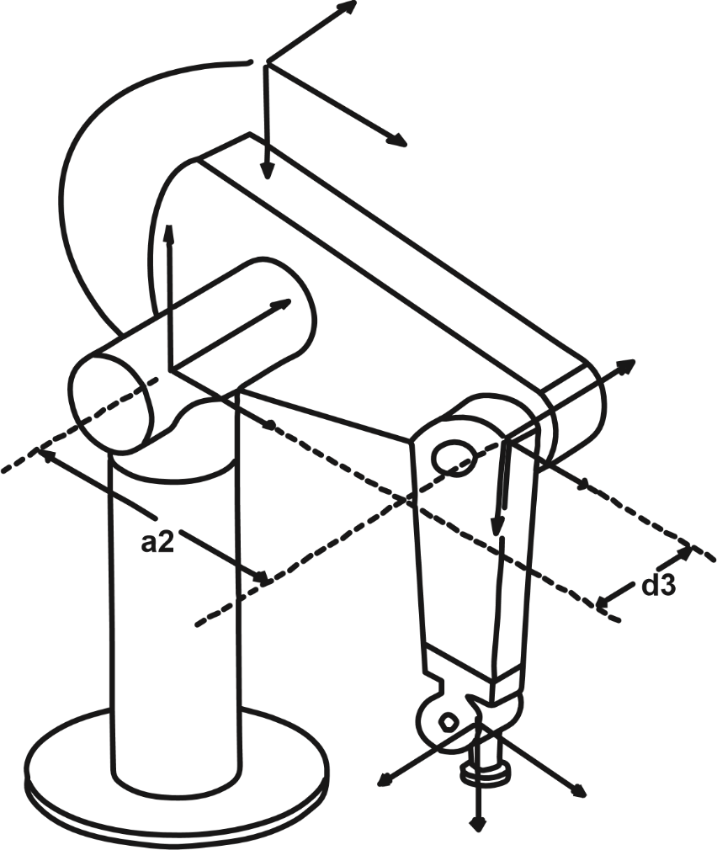

**d4**

**a3**